Nina Compagnon

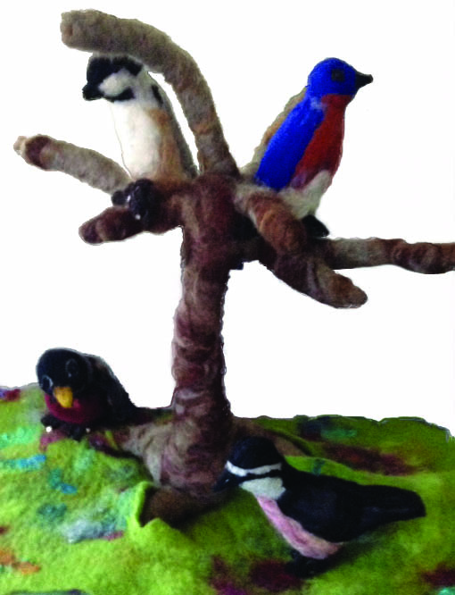

My soul is touched by anything with color and texture. As if hypnotized, I find myself drawn to look more closely and to touch all sorts of things—yarn, fleece, fabric, and things in nature such as moss or lichen. I am drawn to things that shimmer and shine. I have enjoyed weaving, quilting, beading, and, for the past seven years, felting. I primarily nuno felt, making yardage, shawls, clothing, and the occasional needle felted critter. I never seem to tire of felting for there is mystery in the final results; you never really know how your piece will turn out, for wool has a mind of its own that must be respected. The process of felting is akin to therapy, bringing me face to face with myself, forcing me to confront my weaknesses repeatedly until I learn to change. Some days I wonder if I will ever learn! I love felting because I find the process to be captivating, meditative, repetitive, and exalting, all at the same time.

Thoroughly Modern Emily $200
magenta wet felted wool cloche with ostrich feather and silk metallic band

Dress - pieced and nuno felted size 0-2 $275

If only I … large brimmed black merino wet felted hat with $200
aubergine ostrich feather and purple mesh net

Birds of a Feather needle and wet felted birds, tree, grass $500

Individual birds
Eastern bluebird $100
Red breasted nuthatch $100
Black capped chickadee $100
Robin $110
Tree and grass stand $150
Sally Dillon

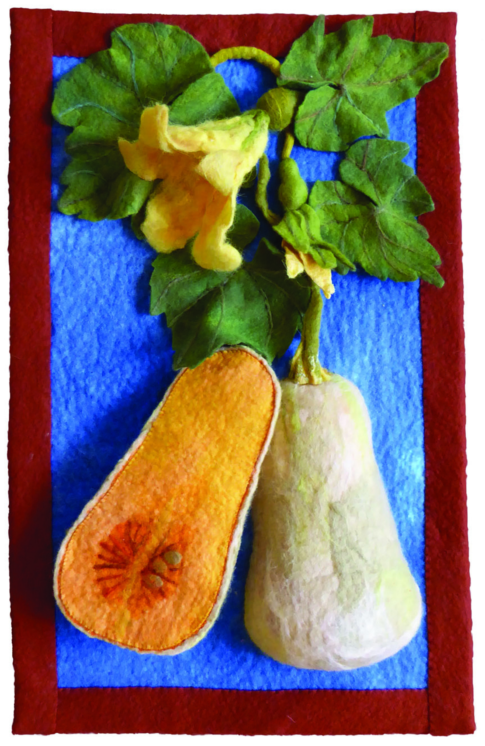

I have been making fiber art for 30 years. For much of that time I painted on silk. Inspired by maps, rocks, and the natural beauty surrounding me, I hand painted silk fabric with dye for scarves, dresses, coats, jackets and quilts, and sold them at galleries and juried craft fairs, including Paradise City Arts Festivals. Six years ago, I turned my attention to making art by felting wool fleece. I use loose dyed and natural fleece from sheep and alpaca to “paint” realistically. When the Amherst History Museum invited our fiber artist group to respond to items in their collection, I chose a screen painted by Mabel Loomis Todd. Like hers, my screen depicts some of the commercial crops grown in the Pioneer Valley: asparagus, apples, maple sugar, butternut squash and tobacco. In addition to appreciating the beauty of each of these plants, I hope the viewer will be surprised and pleased to see how realistic felt “painting” can be.

Crops from the Valley 6 panels on wooden screen $6000.00
hand felted wool fiber

Individual panels $950.00

sally@sallydillon.com
Rebecca Porter Fricke

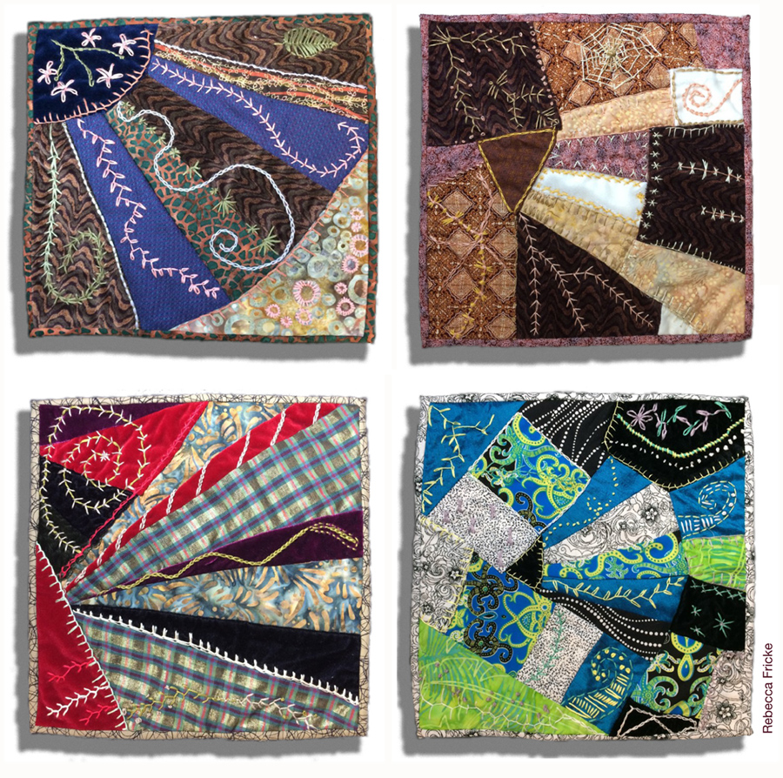

Rebecca Fricke has been an Amherst resident since 2000. She made one quilt for her family in 1999 and then picked up her needle and thread again in 2007. After hand sewing a few quilts, she decided to try out a long-arm sewing machine in 2008 and has never looked back. From bed quilts she moved on to wall art and home decor and it was around that time that she began her art business—Bedscape Designs. During the tour of the back rooms of the museum, Rebecca looked for inspiration in the objects' color and form and was taken with many of the artifacts, so much so that she had trouble narrowing down the possibilities. Eventually she settled on three pieces, each of which forced her to do research and learn new fiber techniques. She is grateful to all of the Amherst veterans who contributed to her flag project based on the North Congregational Church's WWI flag, and she hopes to continue the project beyond the show dates. For the Victorian dress painting, she was inspired by Mabel Loomis Todd’s tendencies to paint on woodwork and her own clothing, and her habit of pinning passionate love notes inside her clothing in case she ran into her lover, Austin Dickinson. Finally, learning how to embroider for her Victorian crazy quilt squares was intriguing, but she's sure that doing more than four would have driven her crazy.

Veterans Service Flag 50” x 69” Not For Sale
canvas and commercial felt

Four Squares, Not Too Crazy 16”x16” each $300
variety of cloth, some of which came from Indonesia.

I Love You and I Love You $100
woman’s cotton undergarment, wool yarn, acrylic paint

The Dress She Never Got to Wear $500
woman’s silk Victorian wedding dress, paper, ink, organza

BedscapeDesigns.com
bedscapedesigns@gmail.com

Martha May

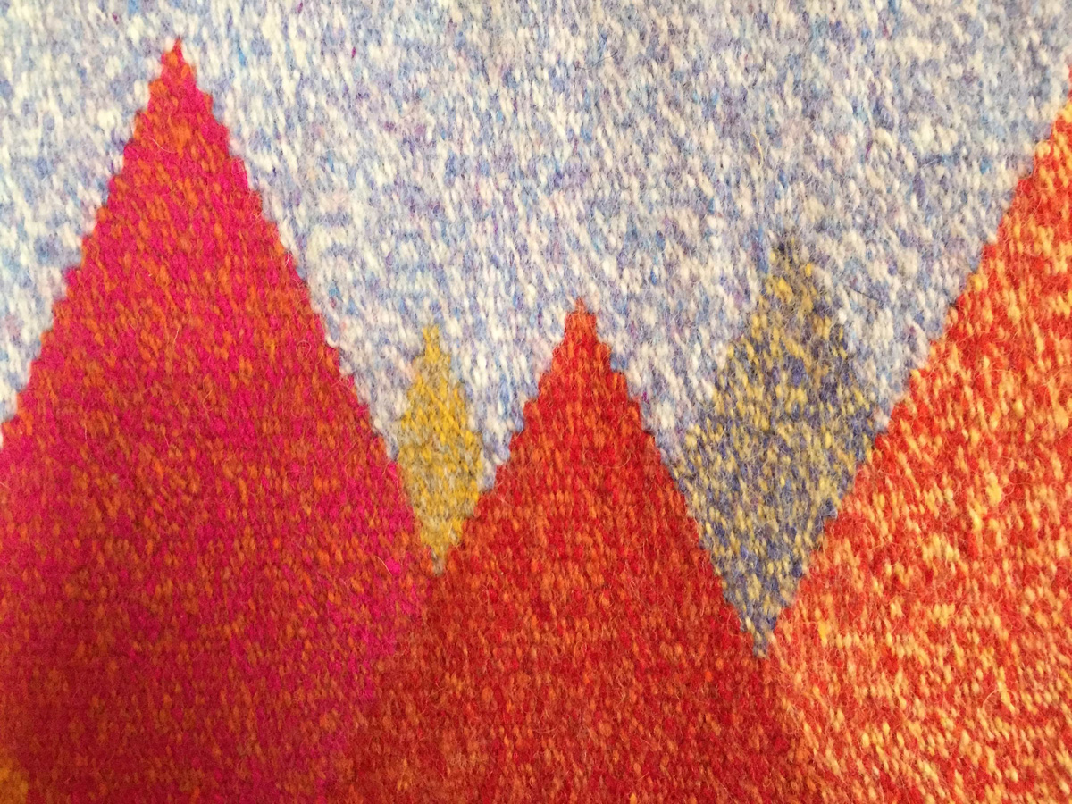

I live in Holyoke MA with my Royal Corgi and Tuxedo Cat and work out of my home based studio. Almost two years ago, while finishing up a machine quilted landscape I had a revelation. My stitching was getting very dense and the hand of my work was changing, and I kept thinking this is more like weaving. So, I started researching tapestry weaving and found myself enchanged by the process. During my research I found an online tapestry course with Rebecca Mezoff, signed up, and studied the basics for six months. Since finishing the course I have been weaving small works, experimenting with color and technique. I’ve got a long way to go but am happy to have found a medium that will hold my interest for many years to come.

Arm 6” x 14.25” $200
wool and cotton

Summer 16.50” x 6.75” $200
wool and cotton

Painted Sky 15.75” x 6.25” $160
wool and cotton

Martha May
Holyoke, MA 01040
yamathram@gmail.com
Martha Robinson

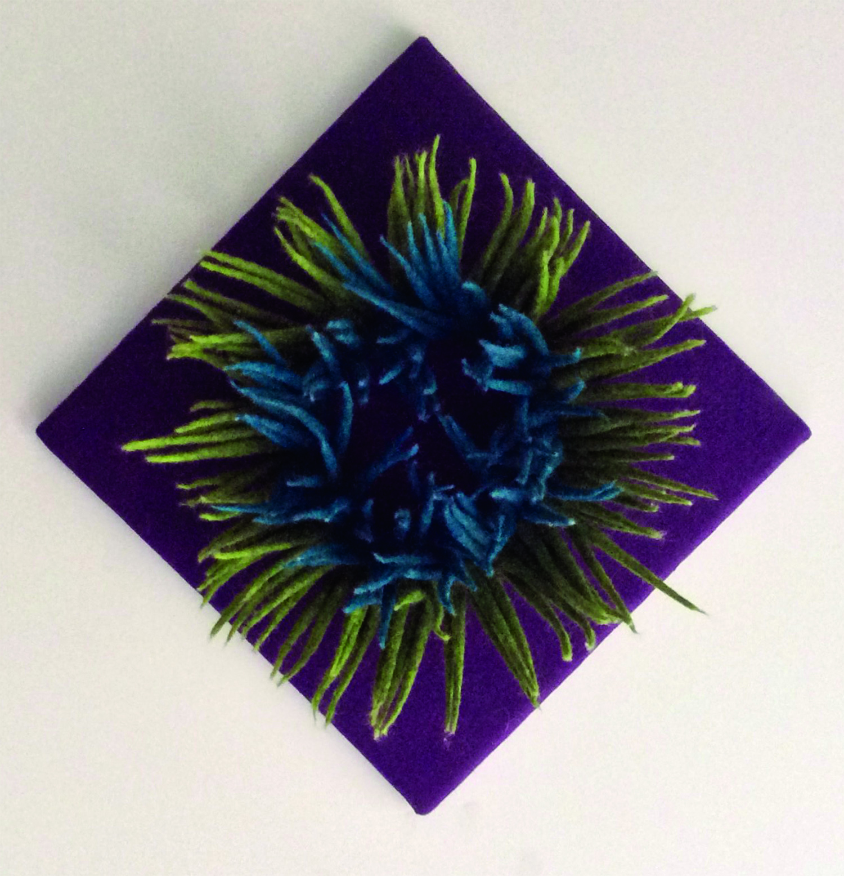

Martha Robinson has been working with fiber in many different versions for more than thirty years. Her interests have included weaving, painting on silk with dyes, quilting, screen-printing, dyeing, and shibori. Her most recent explorations have focused on more sculptural forms. She has always been entranced with the colors and—above all—the tactile quality of fiber art in all its forms.

Bursting Forth 12” square x 5-½”
felted wool spikes on linen ground

Inspired by the tool that turns the stems of the flax plant into useable fiber for making linen, I was intrigued by the contrast of these soft wool spikes with the dangerously sharp metal tines of the original tool. This flax tool in the AHS collection is a compelling shape in itself, but the use of this rather menacing object seems nearly the stuff of folk tales for its part in the magical transformation of flax into linen.

Linsey-Woolsey
felted wool spikes on linen ground, with mixed wool yarn

Linsey-Woolsey is a coarse fabric woven with a linen warp and a wool weft. Here the two fibers are simply sewn together. The same tool inspired both this piece and the nearby Bursting Forth. Linen was a far more common fabric than cotton in earlier times; now linen is much more expensive to produce than cotton fabric.

Now We Work for Annual Giving
silk velvet, vintage porcelain doll hands, vintage cotton bobbin lace

The Victorian doll is a poignant reminder of how differently toys were treated in the past. The doll is clothed as its owner might have dressed on formal occasions. The doll’s facial appearance is quite frozen while the little girl who played with it must have had a very lively imagination. Are her hands poised to engage in play, or are they expressing alarm?

Flo Rosenstock

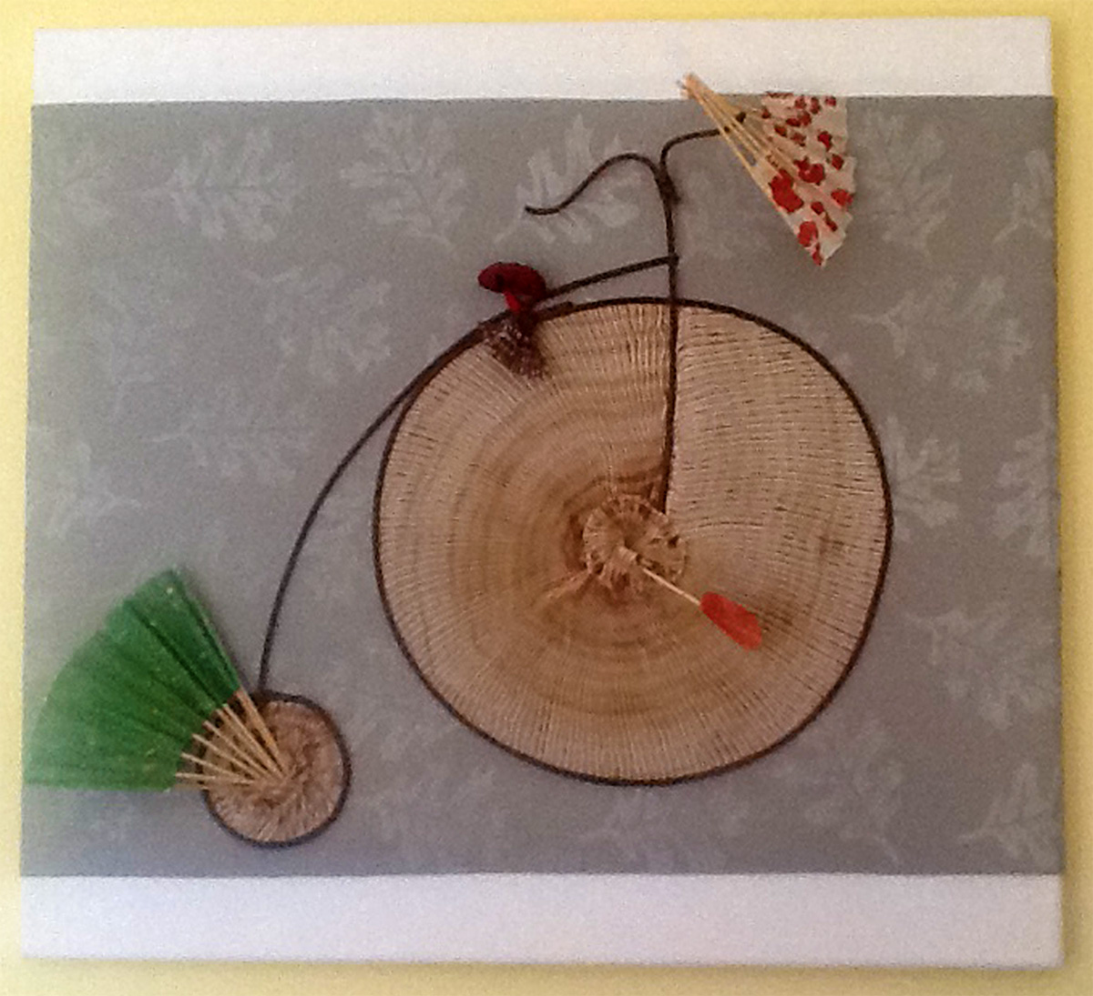

I have lived in Amherst since 1995. Pottery was my first artistic medium, but in the last 25 years I have worked primarily in fiber—silk, felt, and paper. I strive to achieve unusual color and surface design in the materials I employ for my wearable and sculptural pieces. I have always been most excited about working in ways that yield unpredictable results--an unexpected and thrilling hue that emerges from the dye pot when I've layered colors over each other, or the textured surface of a nuno scarf as felted wool gathers up silk. I am strongly influenced by the Japanese tradition of shaped resist dyeing known as Shibori, in which fabric is manipulated by stitching, folding or clamping so that only some portions are exposed to the dyes used to create color. In this way, the interplay of dyed and un-dyed areas creates complex and distinctive patterning.
A Woman Without a Fan is Like a Fish Without a Bicycle 22" x 24" $250
hand dyed and pleated silk, reed, paper
Majestic Sycamore 12" x 48" $150
hand felted wool and silk

Flo Rosenstock
35 Gray Street
Amherst, MA 01002
413 256-4690
florosenstock@hotmail.com

Deborah Jane Slavitt

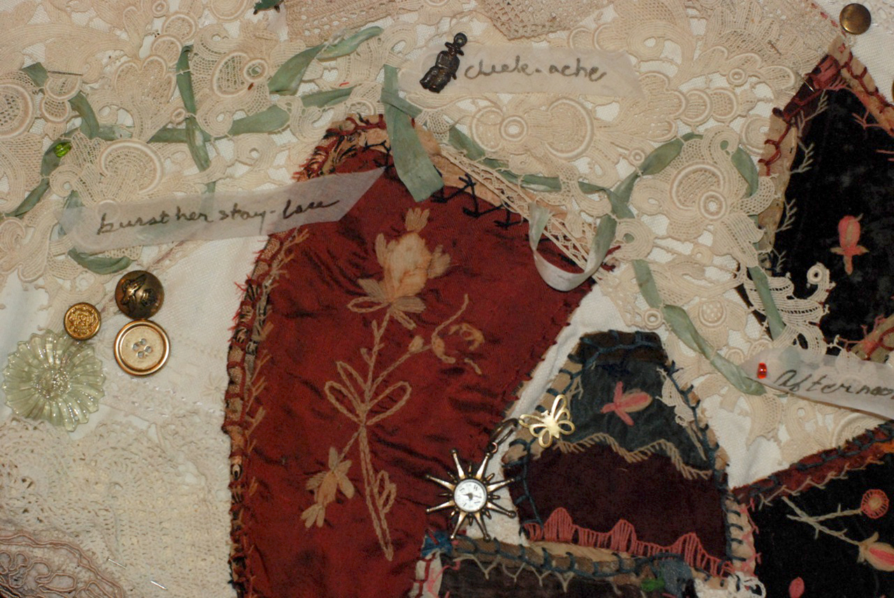

I’ve loved the color and feel of textiles my whole life, sewing my wardrobe in the 60’s - 80’s, creating freeform-crochet hats and accessories, playing with mixed materials a la crazy quilting and printing and dyeing fabrics. I exhibit my fiber art and photography around the Northeast and have published countless travel stories here and in Asia and Europe where I lived for many years. Between leading workshops for kids and adults in the Valley and at Materials for the Arts, NYC, organizing the reuse art area and activities of Northampton’s ReCenter Swap Shop, finishing up the ABC Guide to the Outermost Cape and beginning the Outermost Cookbook, I’m busy with what I love.

In creating my version of a Victorian crazy quilt, I was inspired by the deep pile of white textiles in the Museum of the Amherst Historical Society’s storeroom, the white stairwell and walls leading there, a collection of hat forms and a pile of crazy quilt squares. My piece includes materials collected over the years: white and off-white vintage crochet and lace, remnants of a 19th century crazy quilt from an artist friend who knew I’d love them, brass buttons from my mother’s sewing boxes, ribbons, and hand embroidery.

Labors of Love and Language of the Time 19” x 37” $300

Let us candidly confess our indebtedness to the needle. How many hours of sorrow has it softened, how many biller irritations calmed, how many confused thoughts reduced to order, how many life plans sketched in purple.
Caroline Dall, quoted in “Wise Women About Women,”
Good Housekeeping, June 25, 1887, p. 94.

deborahjane26@mac.com
www.ArtisttoGo.com
Margaret Stancer

As a maker of wearable art, the Emily Dickinson dress appealed to me. It is the only known, surviving article of her clothing. As I read about Emily Dickinson, the dress came to represent, to me, a physical embodiment of the poet, who throughout her lifetime increasingly isolated herself from others. Only a select few read any of Emily’s poems during her lifetime.

The windows of Emily's bedroom, where she wrote her poetry, allowed her to look out on the world around her. As she grew from a young woman into later life, few who entered the gate to the front door ever saw her.

Today Emily Dickinson’s poetry is known around the world, but much of what we know about her is speculation based on opinions of family, friends, acquaintances and scholarly interpretation of existing letters and documents that do not tell a full story. The townspeople of Amherst came to call her the “Myth”. I find that the more I read of her writing and what has been written about her, the more she becomes a compelling and fascinating mystery.

My work with fiber includes wearable art, quilts, and felt, and I hand dye silk, cotton, wool and rayon fabric and fiber for personal use and sale. I have exhibited work regionally, and won prizes for both quilts and wearable art.

Degrees of Separation 37” x 86” x 8” inquire about purchase
silk gauze with stitched silk organza overlays

margaret.stancer@gmail.com
Nancy Young

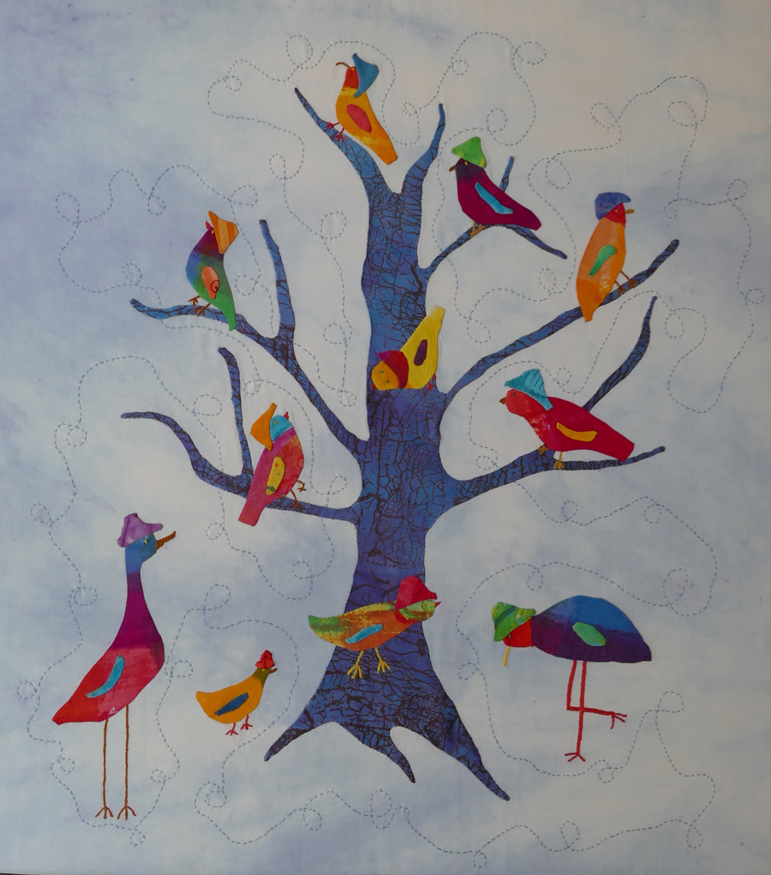

Nancy Young is an accomplished mixed-media artist. In 2013, she completed a two and a half year Art Cloth Mastery program in San Antonio, Texas. She has also taken a number of hand-printing classes. Her work has been shown in the Northeast, including New York City. She was awarded first prize for sculptural forms at the Mid-Atlantic Fiber Conference, and won a monetary prize for a soft sculpture at Convergence, the Handweavers Guild of America’s biennial conference. Her pieces for this show were inspired by some stuffed birds under glass that she saw in one of the exhibition rooms. She used her interest in color, texture, and whimsy to create three bird-related works of art. Hats and Feathers is made of silk that has been dyed, appliquéd, and stitched. The Red Hat Society is printed and painted on silk and is based on a small collaged book. Bird Land is a series of birdhouses made of hand-printed paper.

Hats and Feathers 29” x 26” $400

Red Hat Society 9” x 28” $175

Bird Land Six paper birdhouses $150

nancyyoungartsapce.com
nancy@nancyyoungartspace.com • 413-203-1430

